C Programming: DFA, CFG and NFA Programs
Questions with code and sample output screenshots

Program 1
Question: 1. Write a C program to simulate a Deterministic Finite Automata (DFA) for strings that start with a and end with a.
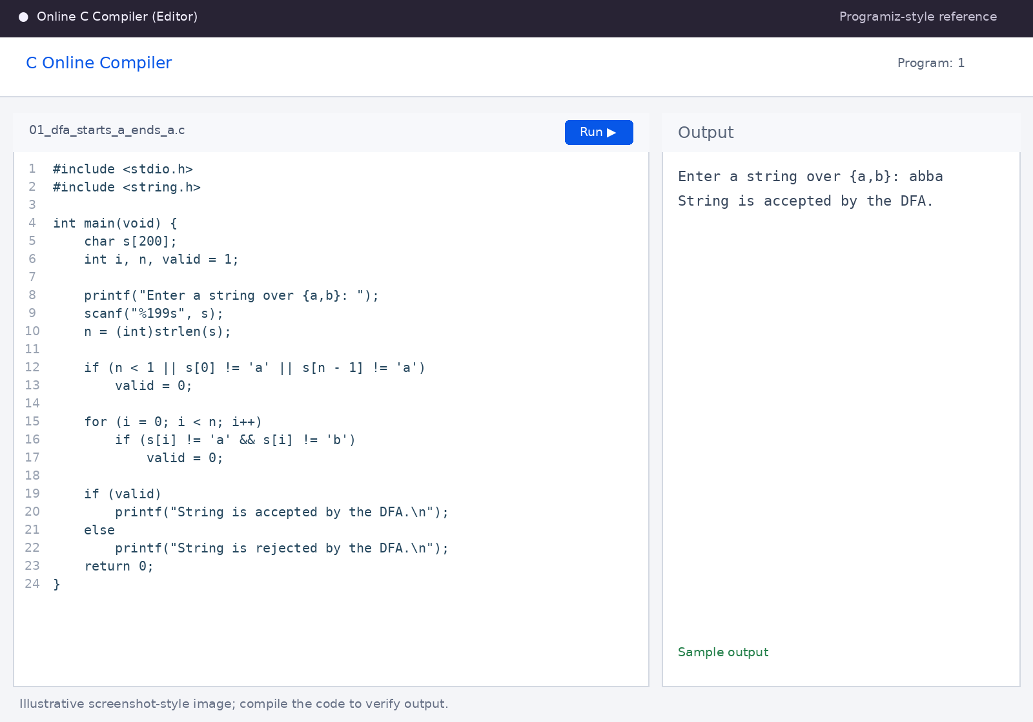
Sample output shown in the screenshot.

Program 2
Question: 2. Write a C program to simulate a Deterministic Finite Automata (DFA) for strings that start with 0 and end with 1.
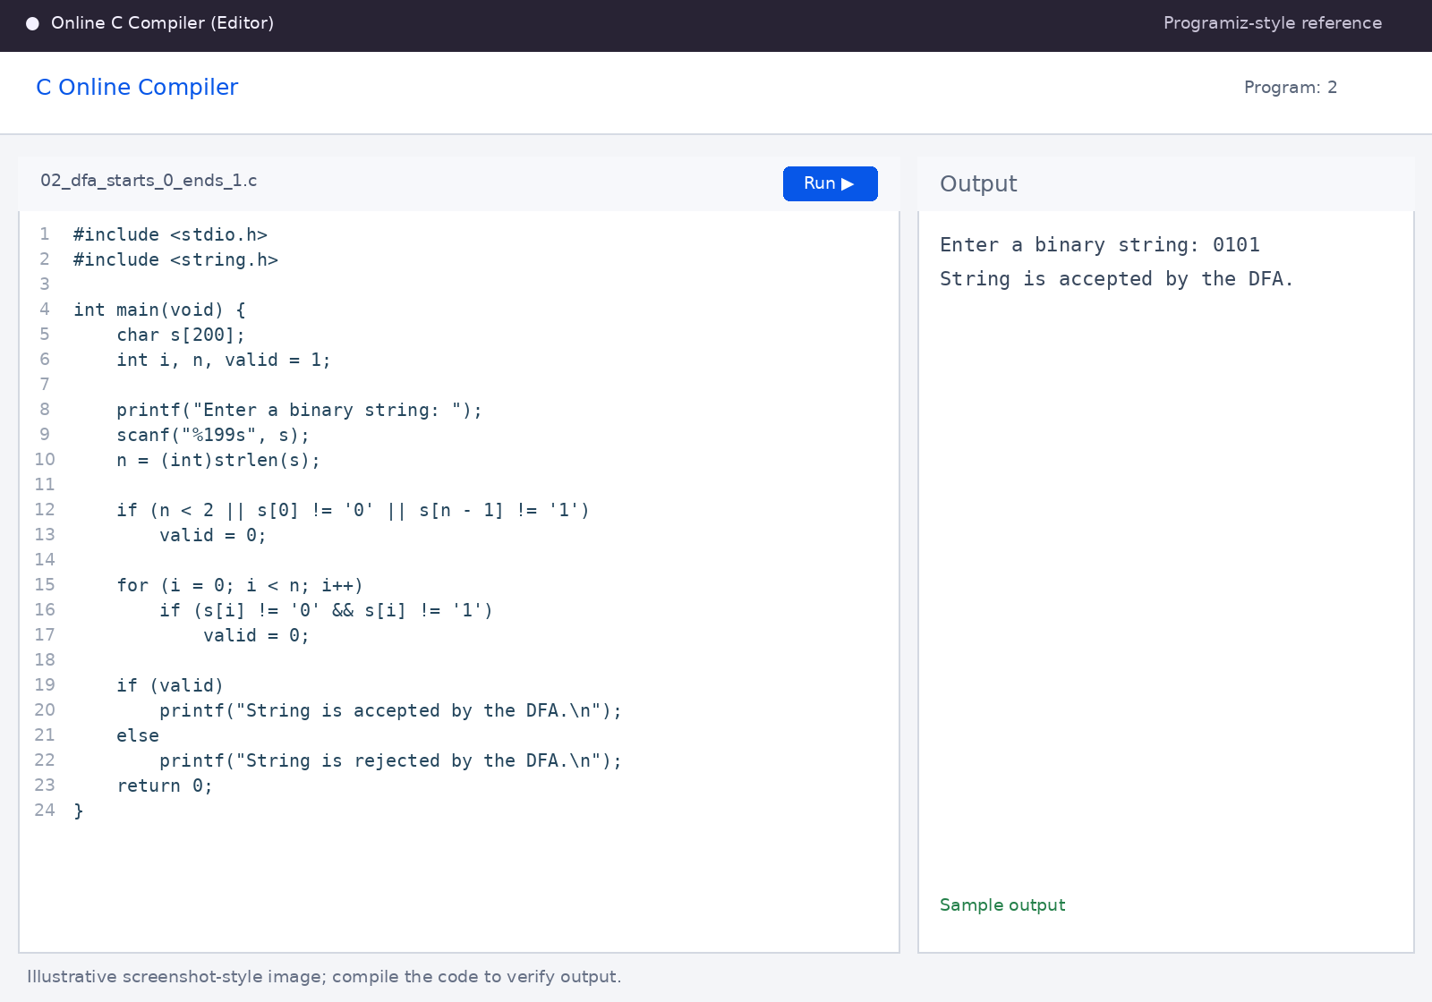
Sample output shown in the screenshot.

Program 3
Question: 3. Write a C program to check whether a given string belongs to the CFG: S → 0A1, A → 0A | 1A | ε.
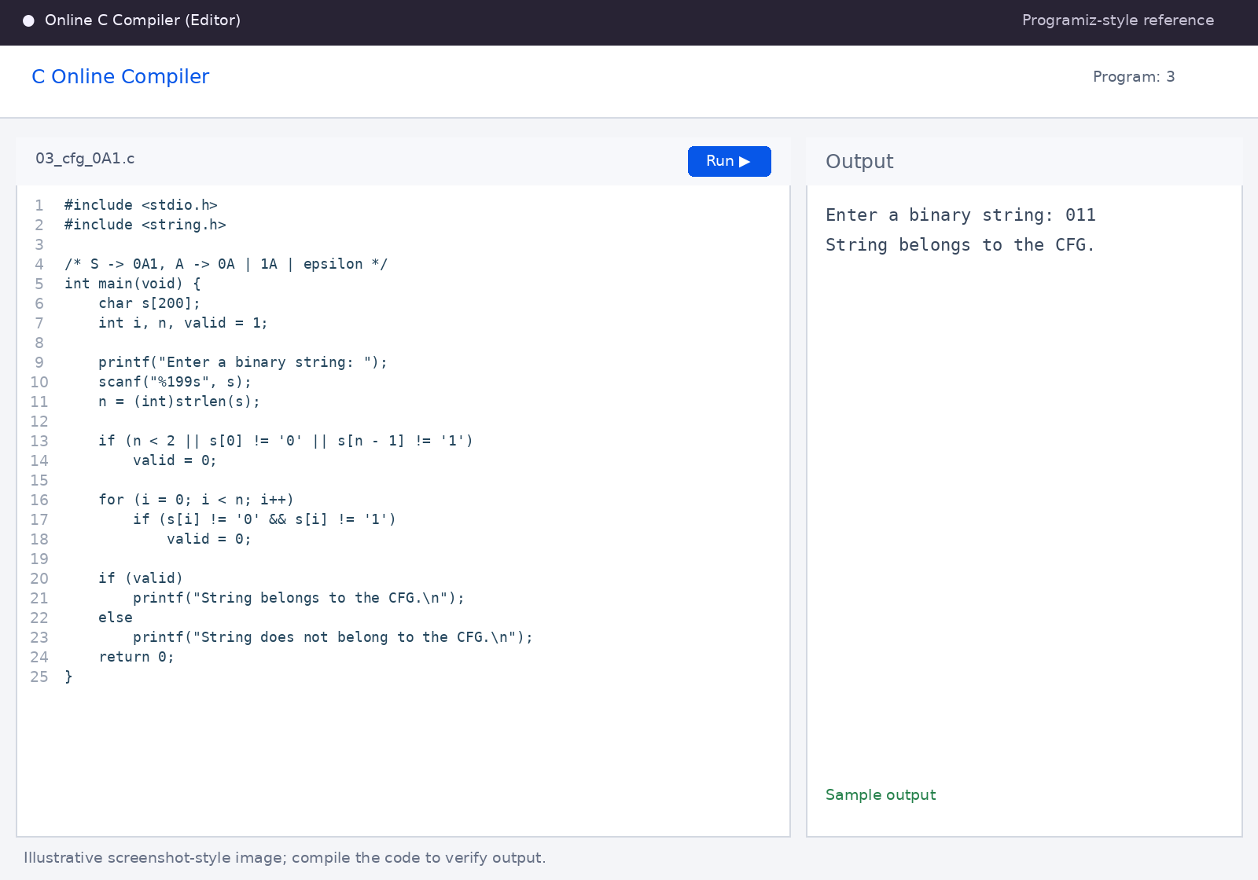
Sample output shown in the screenshot.

Program 4
Question: 4. Write a C program to check whether a given string belongs to the CFG: S → 0S0 | 1S1 | 0 | 1 | ε.
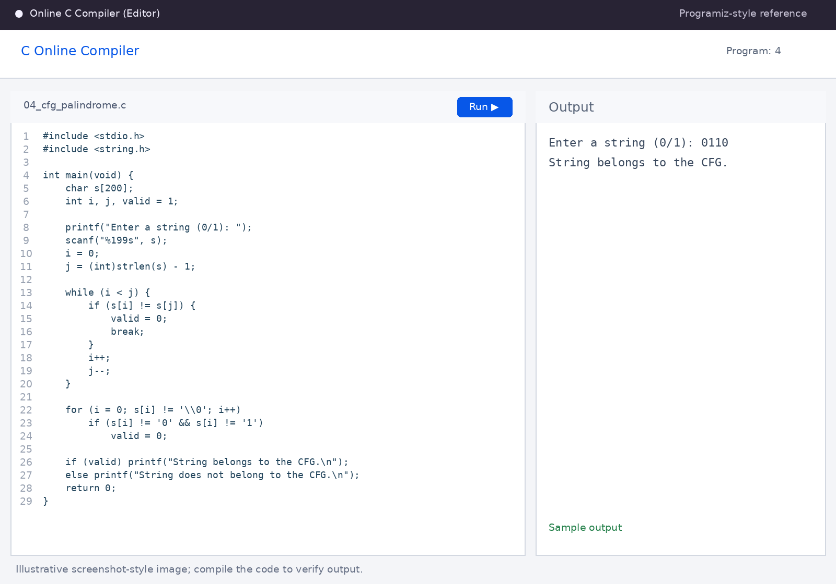
Sample output shown in the screenshot.

Program 5
Question: 5. Write a C program to check whether a given string belongs to the CFG: S → 0S0 | A, A → 1A | ε.
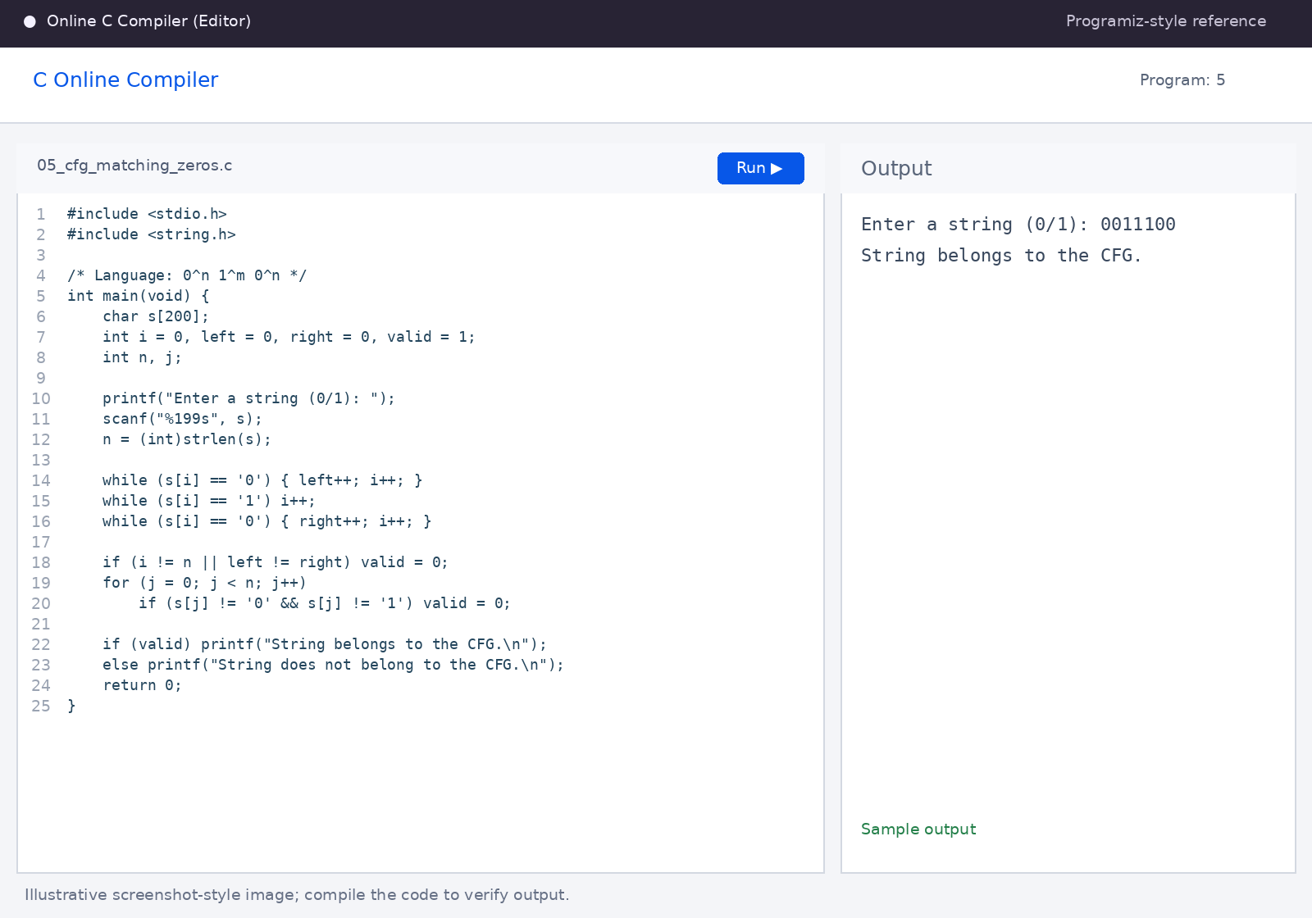
Sample output shown in the screenshot.

Program 6
Question: 6. Write a C program to check whether a given string belongs to the CFG: S → 0S1 | ε.
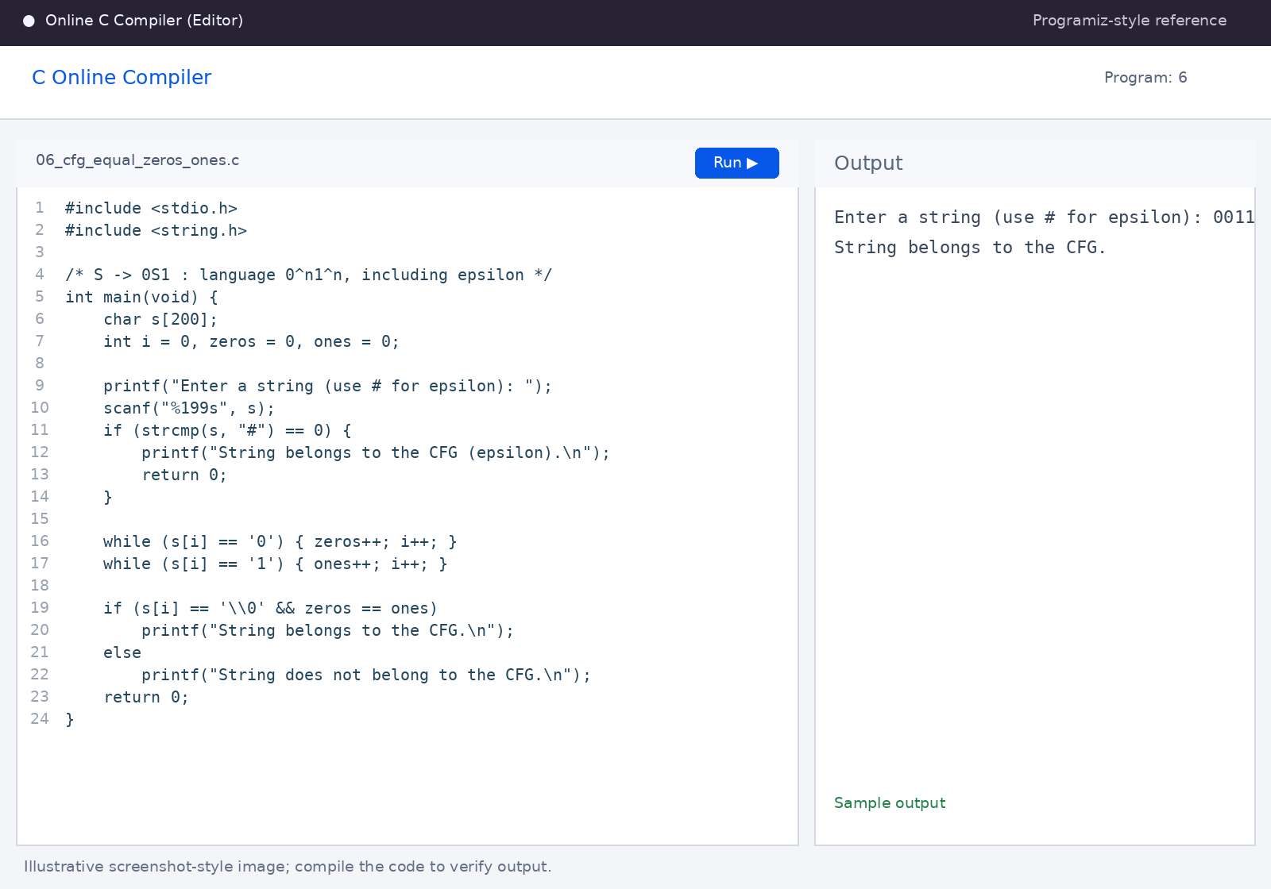
Sample output shown in the screenshot.

Program 7
Question: 7. Write a C program to check whether a given string belongs to the CFG: S → A101A, A → 0A | 1A | ε.
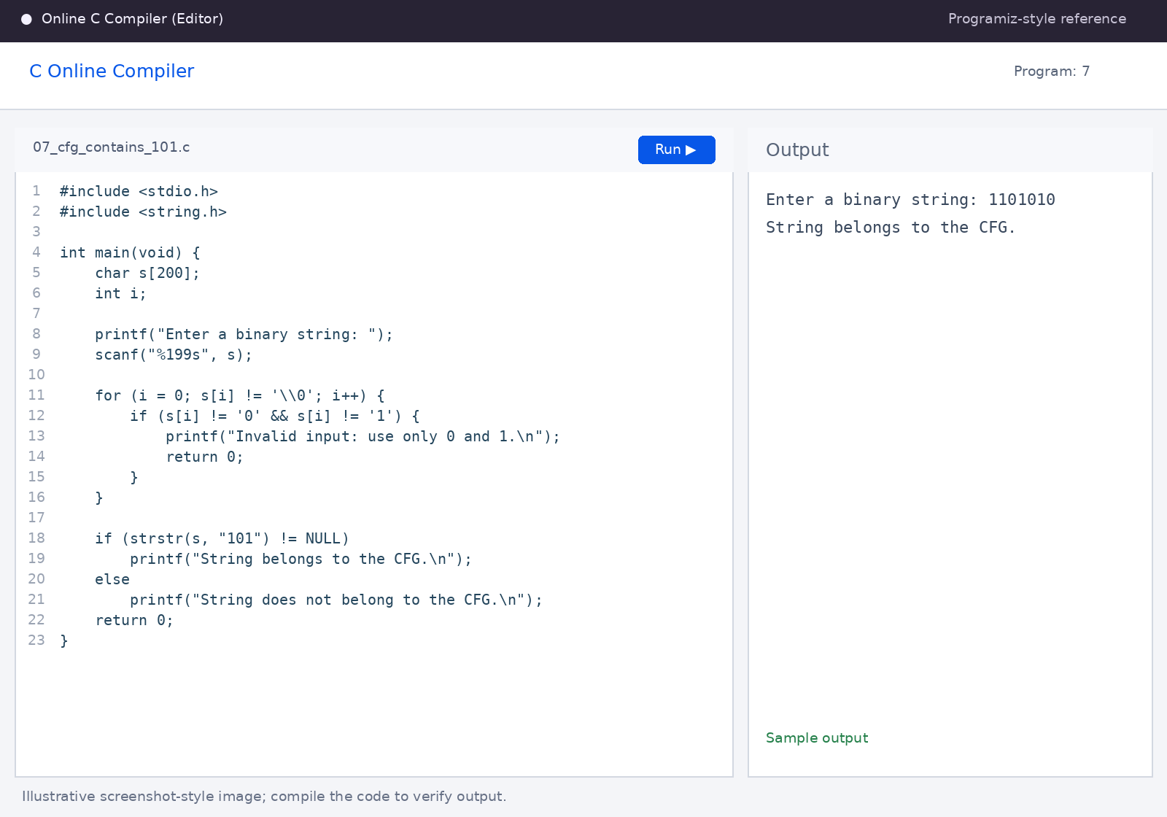
Sample output shown in the screenshot.

Program 8
Question: 8. Write a C program to simulate an NFA for strings that start with b and end with a.
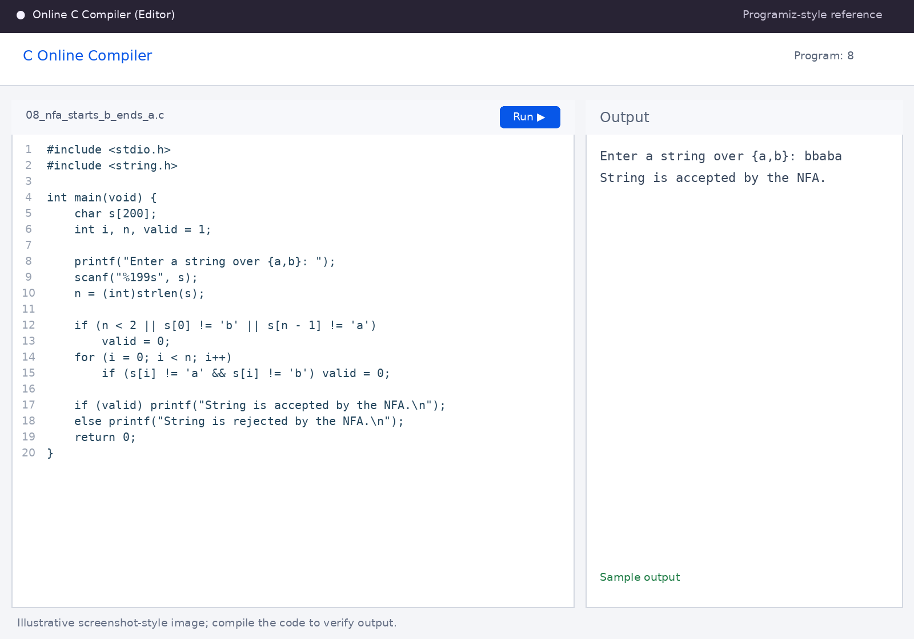
Sample output shown in the screenshot.

Program 9
Question: 9. Write a C program to simulate an NFA for strings that start with o and end with 1.
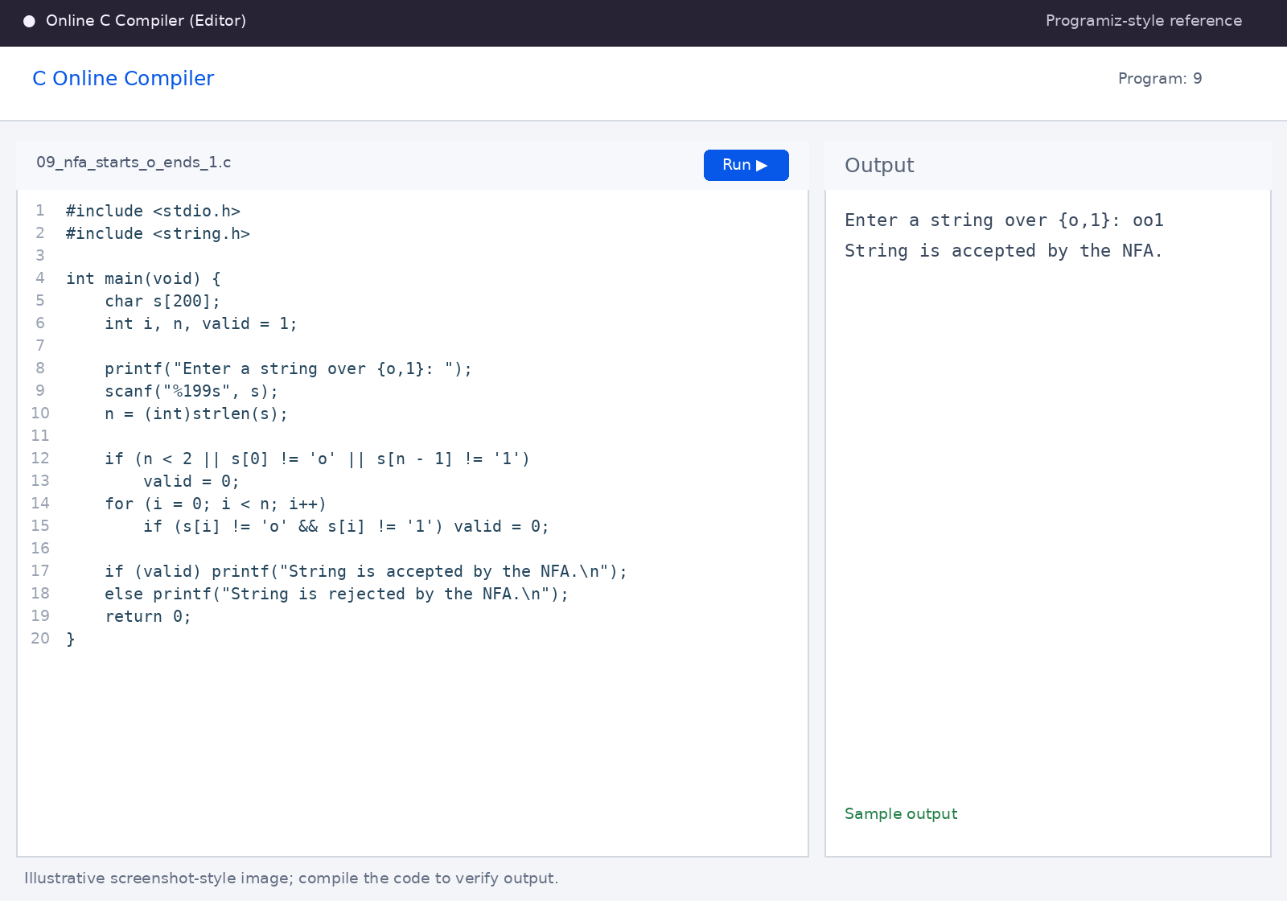
Sample output shown in the screenshot.

Program 10
Question: 10. Write a C program to find ε-closure for all states in an NFA with ε-moves (example: q0 → q1, q1 → q2).
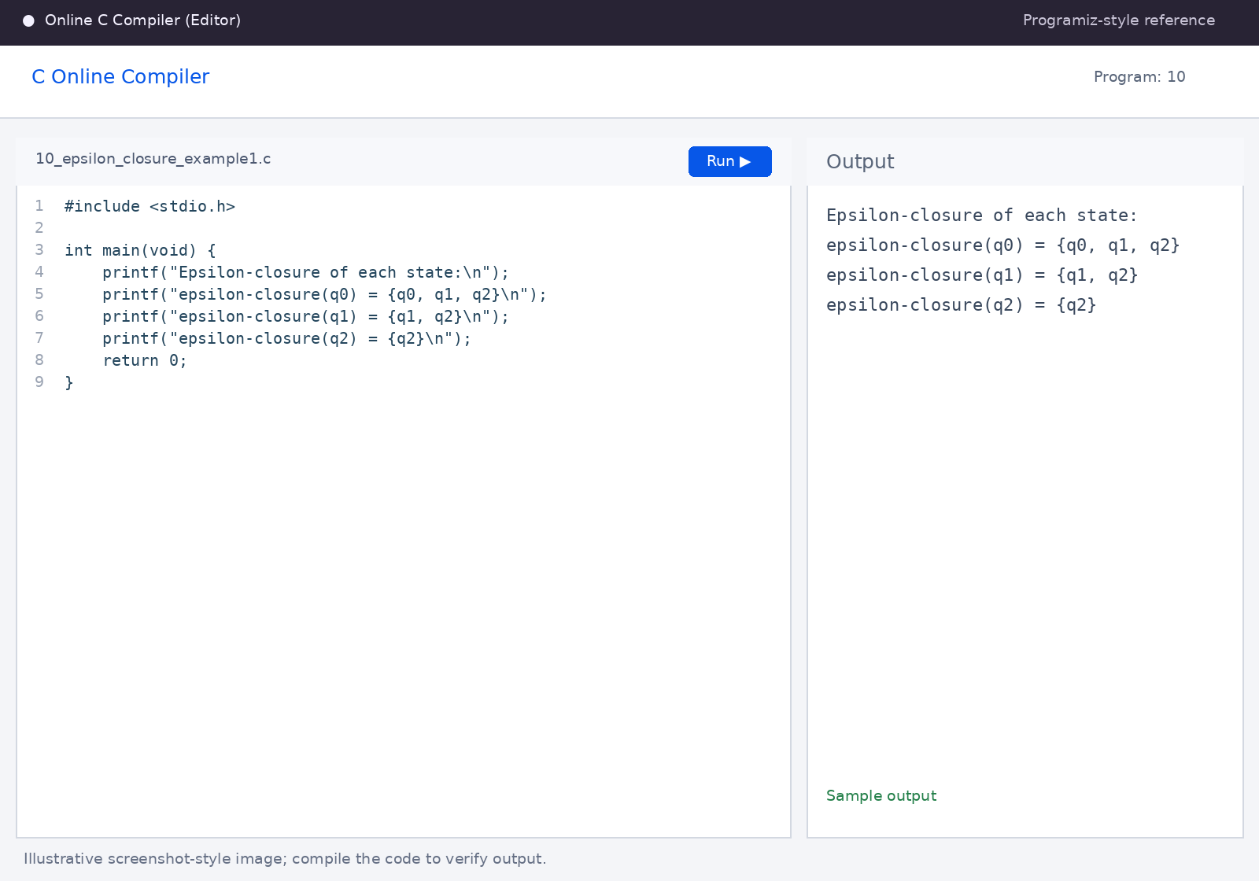
Sample output shown in the screenshot.

Program 11
Question: 11. Write a C program to find ε-closure for all states in an NFA with ε-moves (example: q0 → q1, q0 → q2, q2 → q3).
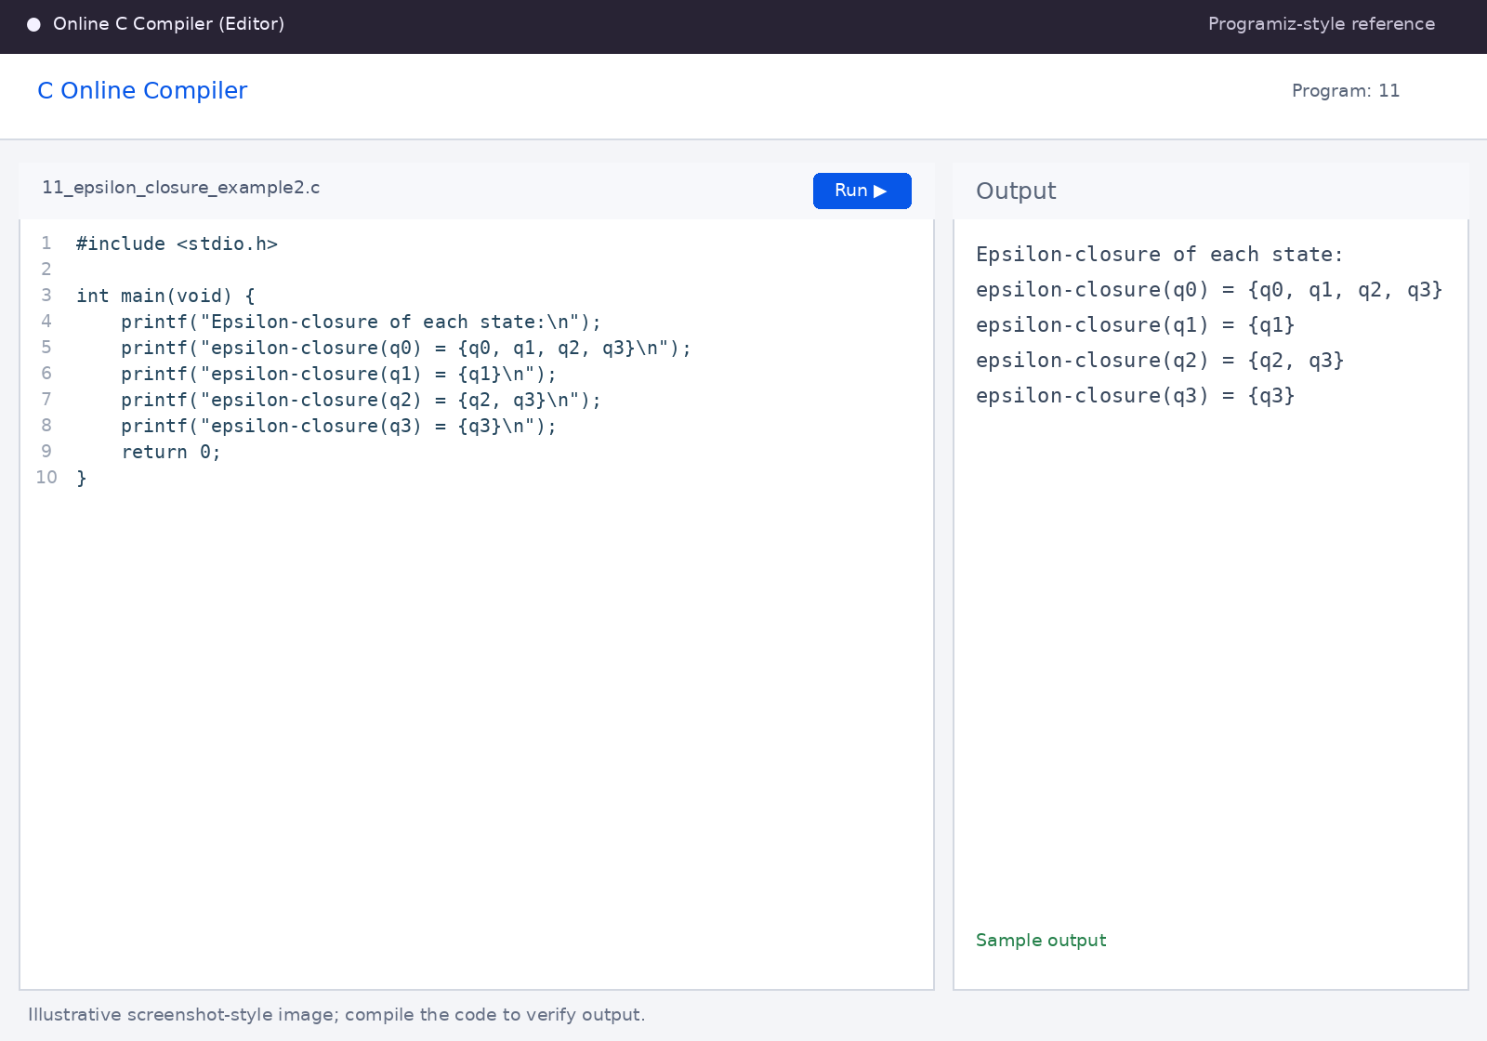
Sample output shown in the screenshot.

